***Shopper Maniac***

This is an Online Shopping Website. It will provide platform for several individuals and companies to sell their products. The application is intended to be small and resource efficient. Application will implement all the CRUD operations on database with strict constriction to DRY principle. The goal of our application is to provide a quick and easy to use interface for all users. The system should be available to be used with the least number of variable factors that can affect it.

***Technology :***

**DataBase:**

* Oracle - SQL (Language)

**Backend:**

* Java 8
* SpringBoot
* Hibernate

**Frontend:**

* HTML
* CSS
* Angular
* TypeScript

***Database Schema :***

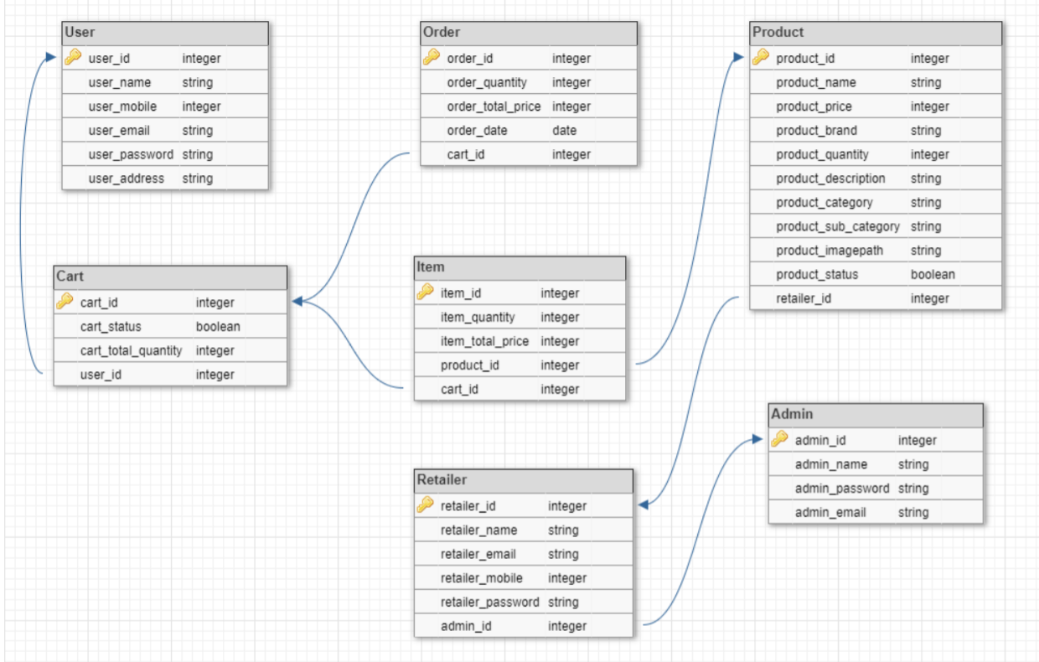

Schema

Following are some Feature which are in the website with Snapshot of them.

1. ***Admin :***
2. Admin can view all products and retailers
3. Add retailer, verify legitimacy of updates done by a retailer
4. Verify Products added by the retailer if legitimate than only approve, hence uploaded to the site for customers to buy.

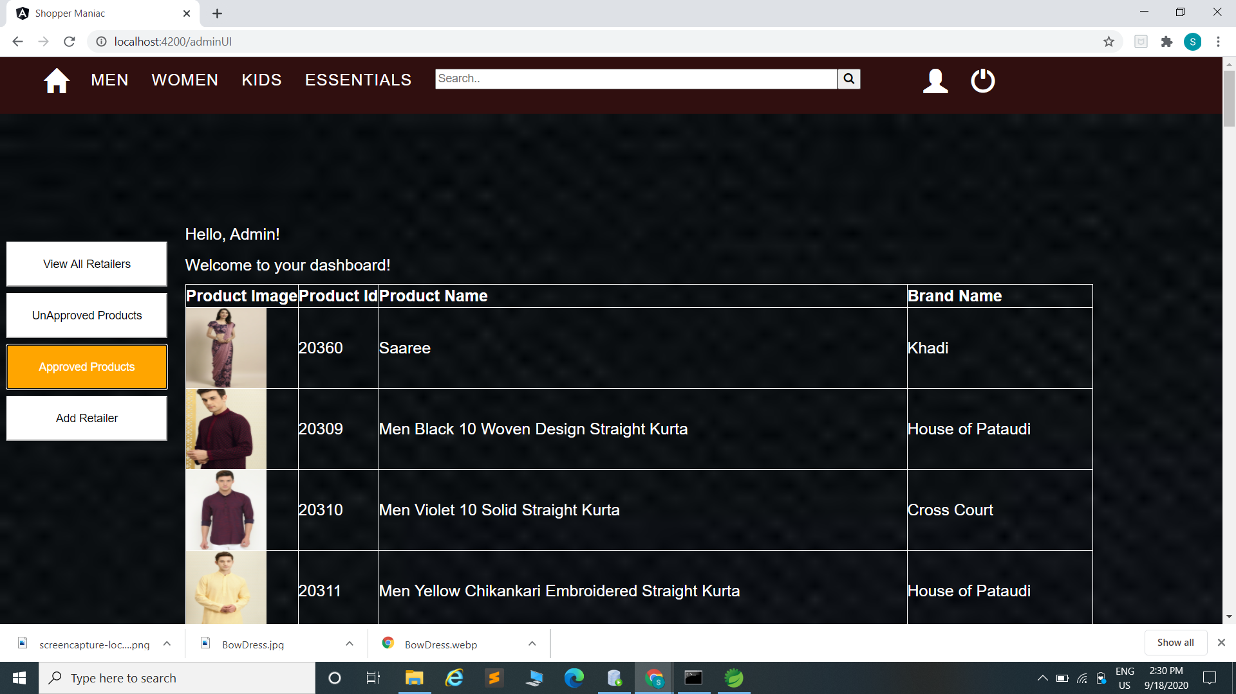

Approve Products

1. Add Retailers (Mail will be send to retailer with their id and password which they can change later on).
2. ***Customer :***
3. Add to cart (update quantity , calculate price )
4. Place order( mail on ordering)
5. Change Password
6. Register / Forget Password (register on ordering, Otp in case of forget password)
7. View their orders / cancel them
8. Login/ Logout

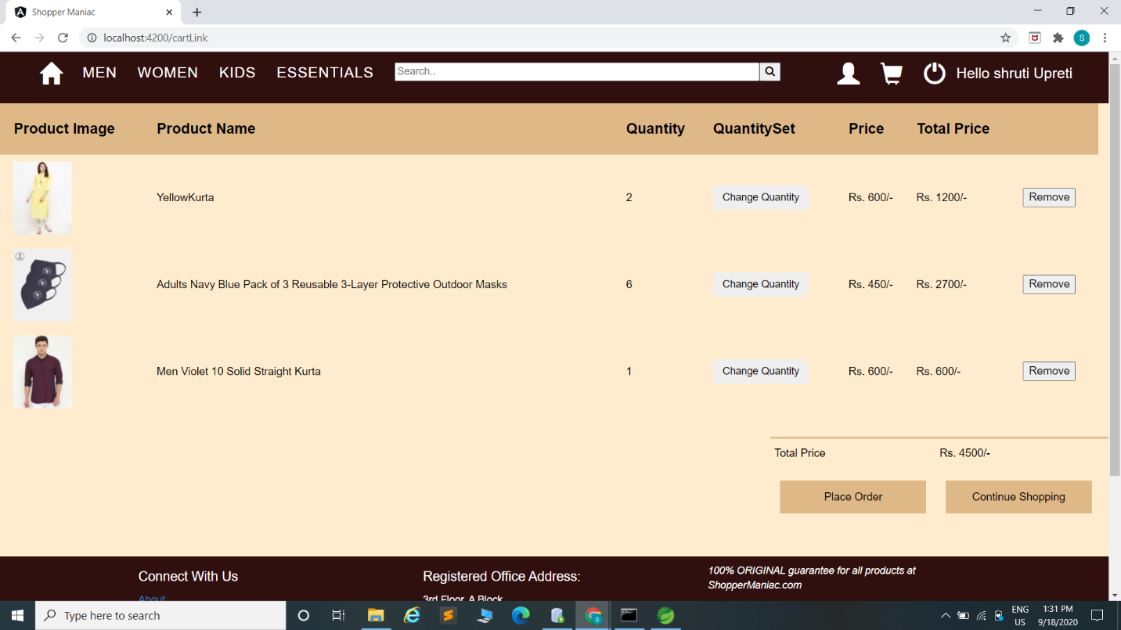

Customer Cart

1. ***Retailers :***
2. Add Products fix their price
3. Update stock
4. Change Password
5. View all the products that he have added

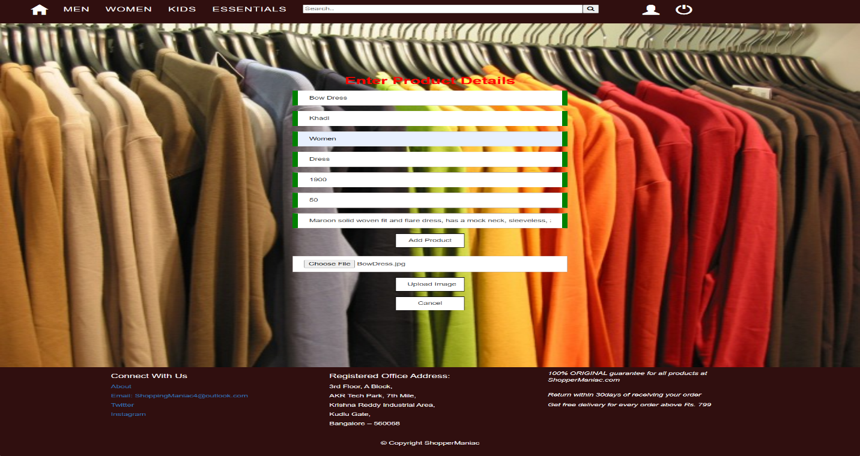

Add Products

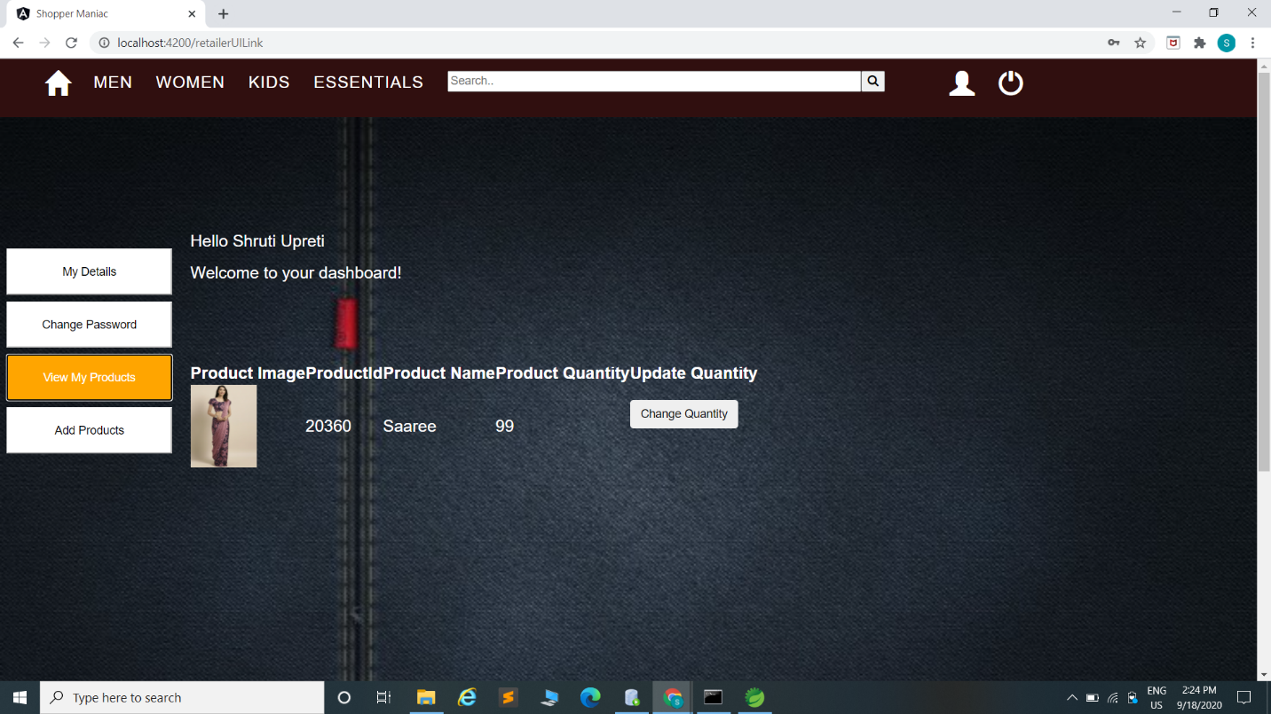

View Products added by the retailer

1. ***Website :***
2. New Arrivals will be shown on the front page
3. Products are divided into 4 categories
4. Men
5. Women
6. Kids
7. Essential
8. Each category is further divided into sub category.
9. Filters are provided on the bases of :
10. Price
11. Sub Categories (Different in each on the basis of categories )
12. Search bar: Customer can search for a product by entering a keyword from either of its name or description.
13. Customer can view product from 2 angles by hovering cursor through them.
14. Customer can see the magnified image of the product if mouse pointer is hovered on the product image.
15. Dashboard / Logout / cart button will be shown on the header once Customer is logged in
16. Add to cart (Only after login)

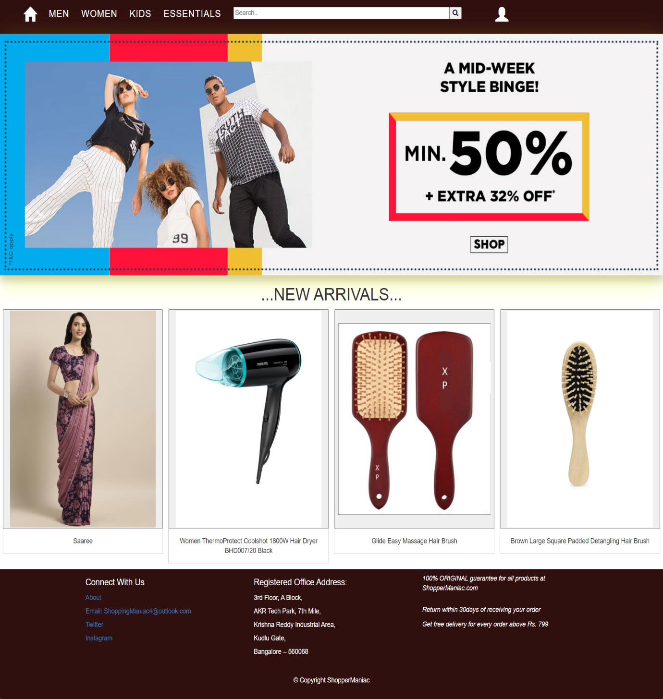

HomePage

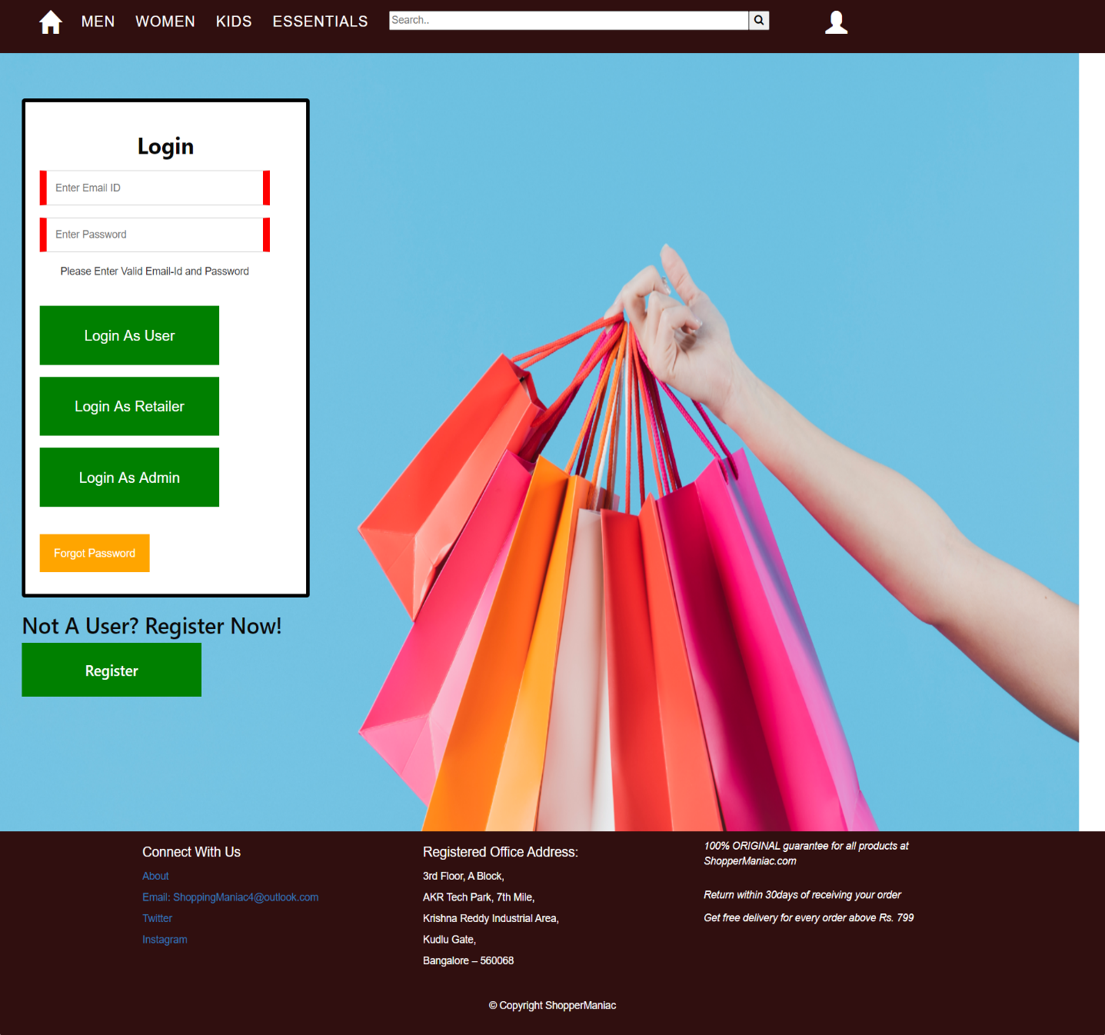

Login Page

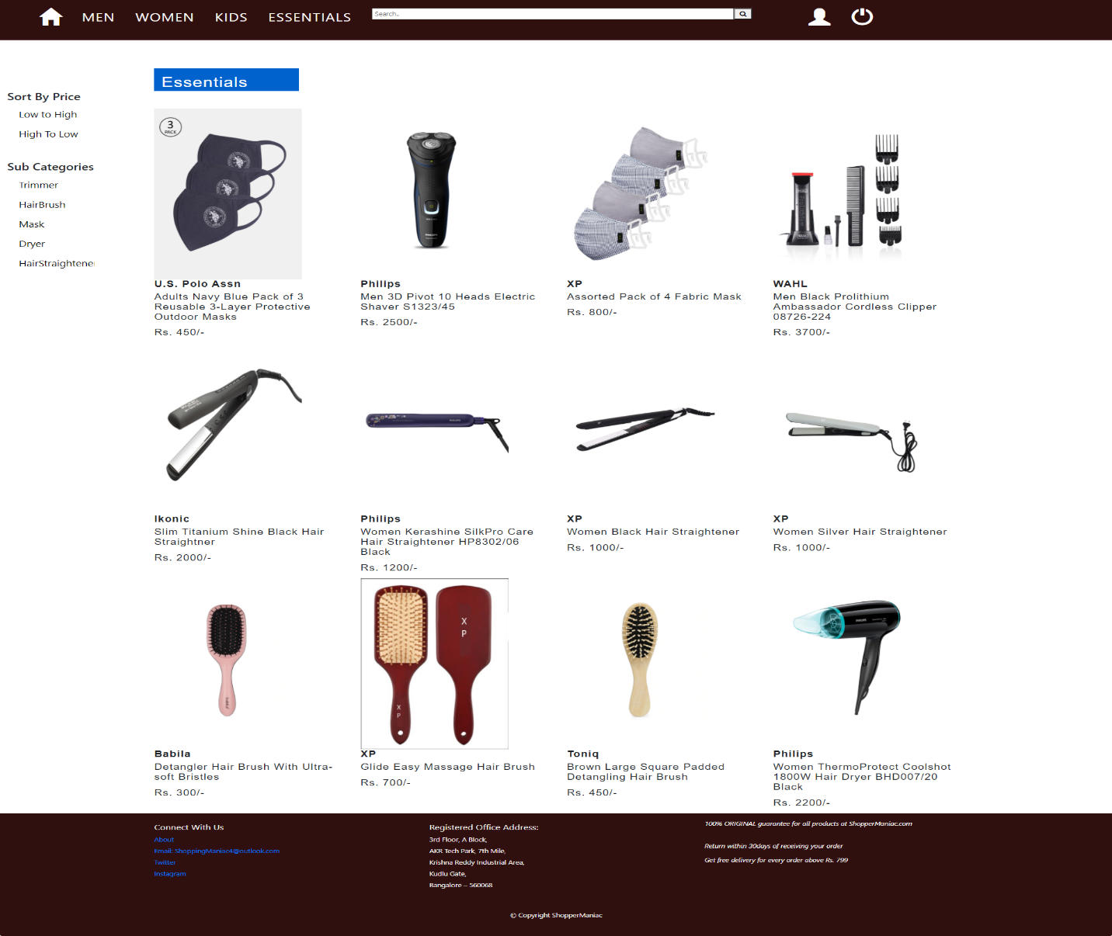

Essential Category with their subcategory

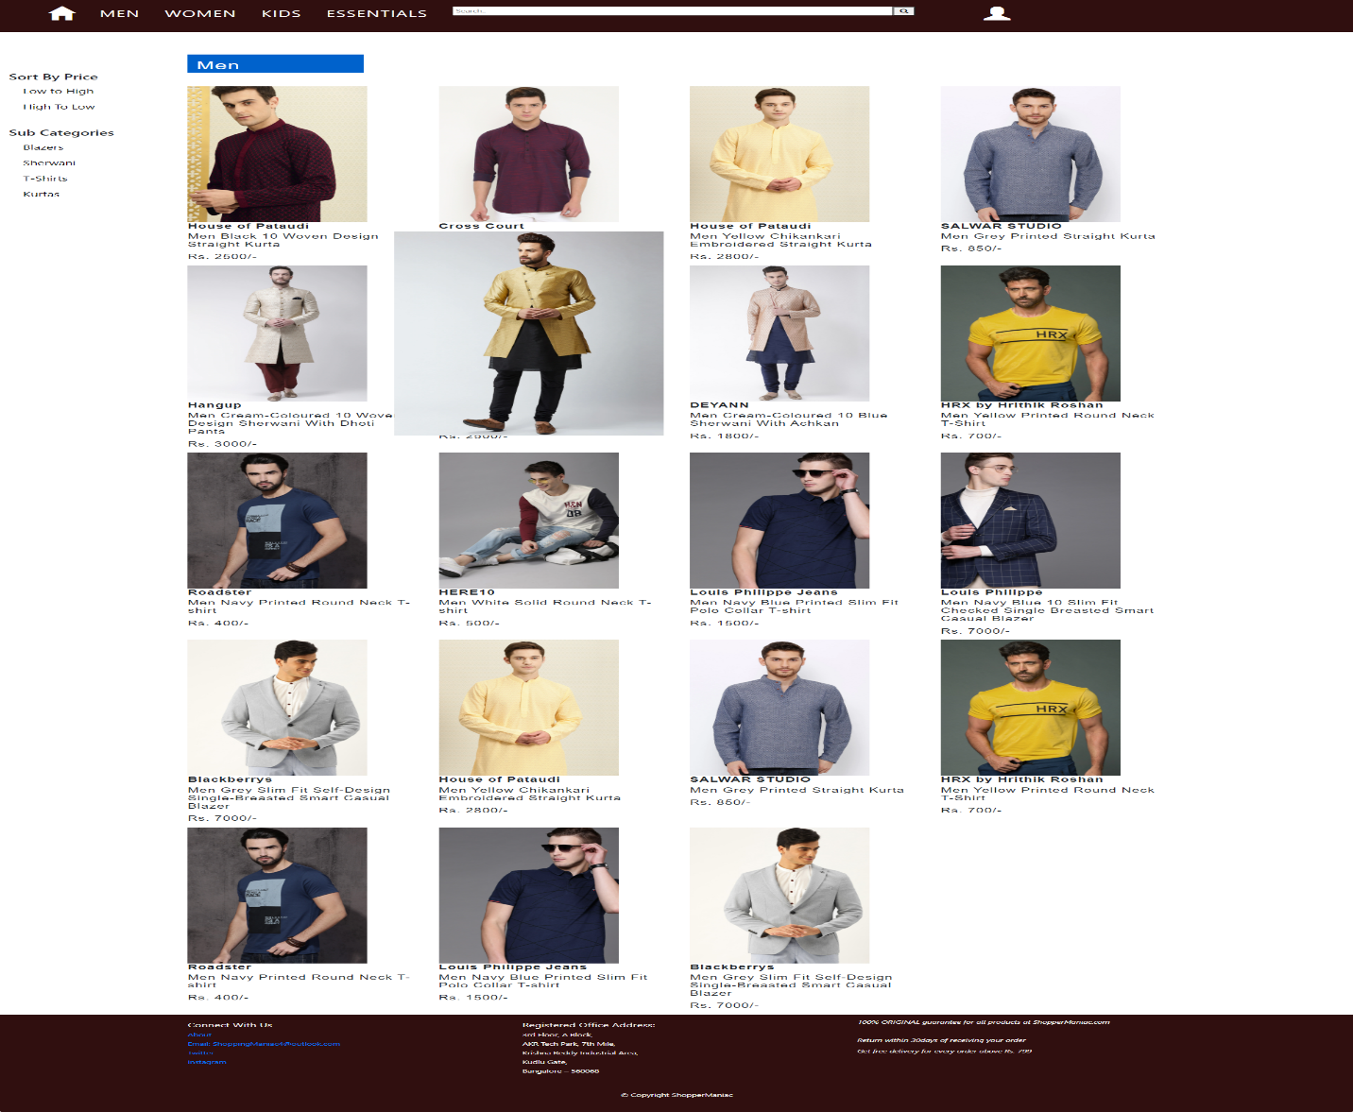

Men’s Category with subcategory and filters